WEATHER CLASSFICATION USING IBM CLOUD VISUAL RECOGNITION

PRESENTED BY
SAKTHIVEL G(710021106032)
ANNA UNIVERSITY REGIONAL CAMPUS COIMBATORE
NM ID:au710021106032
INDEX
1.INTRODUCTION
Project overview
Purpose
2.IDEATION&PROPOSED SOLUTION
Problem statement
Proposed Solution
3.IBM CLOUD MANAGE
Registration
WatsonStudio
Watson MachineLearning
ObjectStorage
ModelTraining and Deployment

4.CODING&SOLUTIONING
Collection of dataset
Loading the dataset
Image Preprocessing
Feature engineering
Building the model
Training the model
Testing the model
5.RESULT
Evalution of accuracy
Github link

1.INTRODUCTION
Image recognition is a field of computer vision that has seen tremendous growth in recent years.With IBM Cloud Visual Recognition,we can unlock the full potential of this technology and create powerful applications that can analyze and understand images.In this presentation,we will explore the capabilities of IBM Cloud Visual Recognition and how it can benefit your business.
1.1 PROJECT OVERVIEW
This project aims to develop a weather classification system using deep learning techniques, specifically leveraging the capabilities of the IBM Cloud platform. The system will utilize deep neural networks to automatically classify weather conditions based on images.

By utilizing the IBM Cloud infrastructure, the project will benefit from its scalable computing power, extensive AI toolkits, and efficient data management capabilities. The project will encompass the development of deep learning models, training and evaluation processes, as well as the deployment and integration of the crime classification system on the IBM Cloud platform.

This report provides an overview of the project objectives, methodology, and the utilization of IBM Cloud resources for the successful implementation of the weather classification system.

1.2 PURPOSE

The purpose of this project is to develop a weather classification system using deep learning techniques. This project will be immensely valuable to the weather forecasters, meteorologists to know about the weather conditions in different places at the same time. The ultimate goal of this project is to assist the meteorologists in their field of work by updating them the weather conditions of different places time to time.

Specific Goals :
• Developing a robust and accurate weather classification tasks
• Using Transfer Learning Techniques to achieve a better accuracy.
• Evaluating and optimizing the model
• Create a web Application that enables the user to upload the images and get the results.

2.IDEATION&PROPOSED SOLUTION

2.1 PROBLEM STATEMENT

My Customer is a meteorologist/a scientist who monitors weather in multiple places. But it is not possible to gather data simultaneously without human assistance and satellite assistance. So he needs a solution to get the climate data up to date and in an accurate manner. So we built a solution to detect images using Transfer Learning which solves our customer’s problem better.

REALTIME USE CASES

- Meteorologist
A Meteorologist monitor climates in multiple places. But it is not possible to gather the climate details of multiple places simultaneously.
So this model gives solution to the above problem by updating the weather of multiple places time to time.
- Traveller:
A Traveler needs to know the climate in a particular place. But It is not possible to get an up to date information.
He/She may be worried about the unknown weather in a place and it spoils his/her travel plan.
Thus this model massively helps in solving a traveler's problem.
- Smart Home Company:
A Smart Home Company needs to know the climate of a particular region. But It is not usually accurate and updated.
Thus this model massively helps in solving a smart home company’s problem.

PROBLEM STATEMENT OF METEROLOGIST

PROBLEM STATEMENT OF TRAVELLER

PROBLEM STATEMENT OF SMART HOME COMPANY

PROPOSED SOLUTION
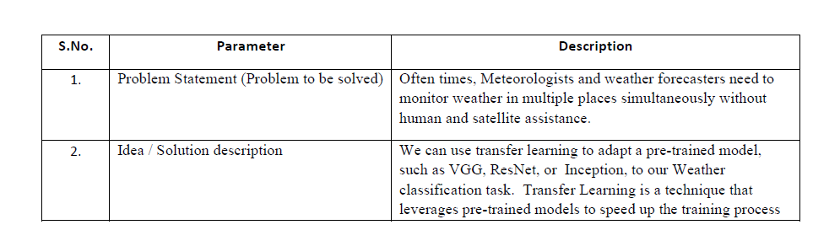

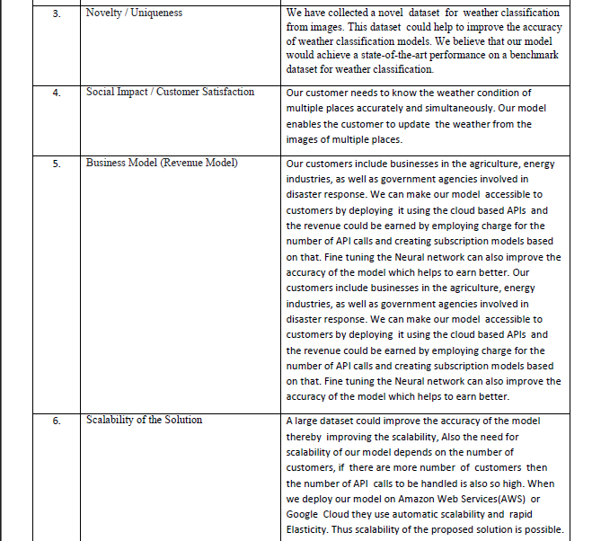

3. IBM CLOUD MANAGE

3.1 REGISTRATION

In IBM Cloud, a register is a process of creating an account to access the services and resources provided by the IBM platform. Go to IBM Cloud website (https://cloud.ibm.com). Click on the "Create an IBM Cloud account" or "Sign up" button. It's directed to the registration page. Fill in the required information to create IBM cloud account.

3.2 WATSON STUDIO
In this project, we leverage the capabilities of IBM Watson, a comprehensive suite of AI-powered tools and services, to enhance the development and implementation of our advanced crime classification system.

Specifically, we utilize the IBM Watson platform to access and utilize its deep learning frameworks, such as IBM Watson Studio and IBM Watson Machine Learning. These tools enable us to develop sophisticated machine learning models using Notebooks and code-free tools to infuse AI throughout your business.

Additionally, the scalability and reliability of the IBM Cloud infrastructure provided by IBM Watson facilitate efficient data management, model deployment, and integration into our crime classification system. By utilizing IBM Watson, we ensure access to cutting-edge AI technologies and resources, empowering us to achieve accurate and efficient crime classification results.
3.3 WATSON MACHINE LEARNING
This project leverages IBM Watson Machine Learning, a vital component of the IBM Watson platform, to optimize the training, deployment, and seamless integration of our deep learning models for crime classification.

By harnessing the capabilities of IBM Watson Machine Learning, we enhance the performance of our models, fine-tune hyperparameters, and streamline the training process. Furthermore, we benefit from the efficient deployment mechanisms offered by IBM Watson Machine Learning, enabling smooth integration of our models into the broader crime classification system.

3.4 CLOUD OBJECT STORAGE
Our project relies on the robust capabilities of IBM Object Storage for the efficient management and storage of extensive crime data utilized in our deep learning models. With IBM Object Storage, we benefit from a cost-effective and highly durable cloud storage infrastructure, ensuring the secure retention and retrieval of crime scene images, textual descriptions, and other relevant data.

This solution enables seamless availability and accessibility of the data throughout the training and evaluation phases of our weather classification system.

3.5 MODEL TRAINING AND DEPLOYMENT
Cloud's Model Training and Deployment services optimize deep learning model training and deployment for crime classification, enhancing efficiency. The parallelization of training tasks offered by IBM Cloud Model Training significantly reduces training time. We achieve faster training times for complex models on large datasets. Following figures show how we deployed on IBM cloud.
4.CODING&SOLUTIONING
4.1 COLLECTION OF DATASET
Determine the weather categories you want to classify. Common categories might include "sunny," "cloudy," "rainy," "snowy," "stormy," etc.
Collect various weather-related parameters, such as temperature, humidity, precipitation, wind speed, atmospheric pressure, and more.
Link:https://www.kaggle.com/datasets/vijaygiitk/multiclass-weather-dataset
4.2 LOADING THE DATASET
The dataset is downloaded from Kaggle and the zip file is unzipped using a small snippet of code.
I mounted the drive on google colab for further machine learning process.
The necessary libraries are imported such as tensorflow, numpy, etc. The images are loaded using the flow from directory().
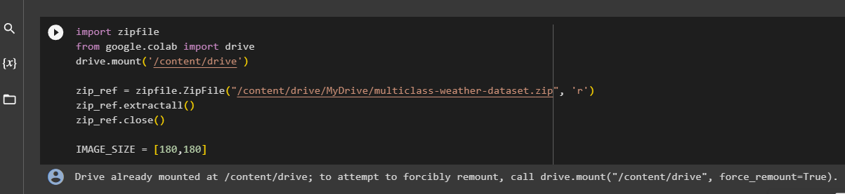

4.3 IMAGE PREPROCESSING

Image preprocessing is done using the Image Data Generator().
It is used for the generation of the batches containing the data of tensor images and is used in the domain of real-time data augmentation.
We can loop over the data in batches when we make use of the images.
The images need to be resized and the zoom range and shear range are passed as parameters.
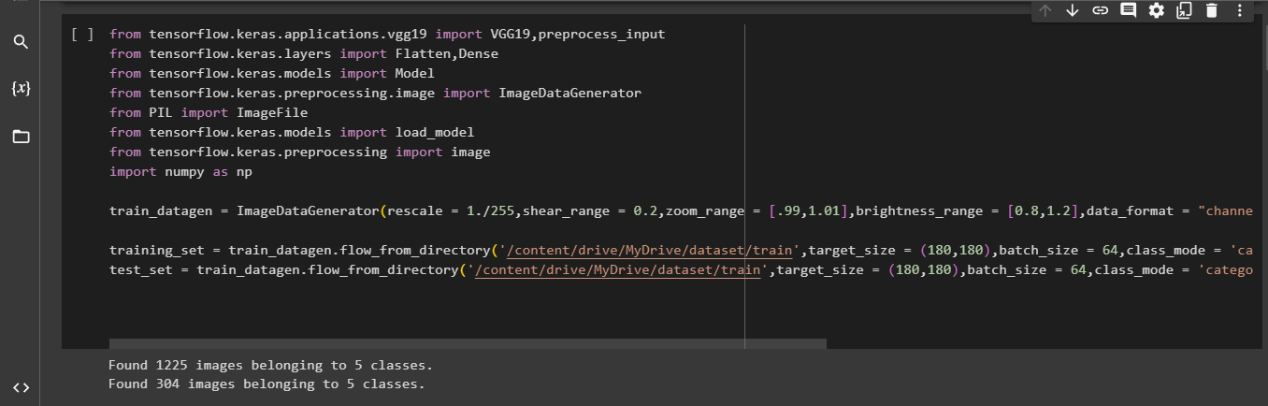
4.4 FEATURE ENGINEERING
Feature engineering in machine learning involves selecting, transforming, or creating meaningful input variables from raw data to improve model performance.
It encompasses tasks such as feature selection, data transformation, dealing with categorical data, and handling missing values.
Effective feature engineering can significantly enhance the accuracy and generalization of machine learning models, often requiring domain knowledge and an iterative approach to refine feature choices.
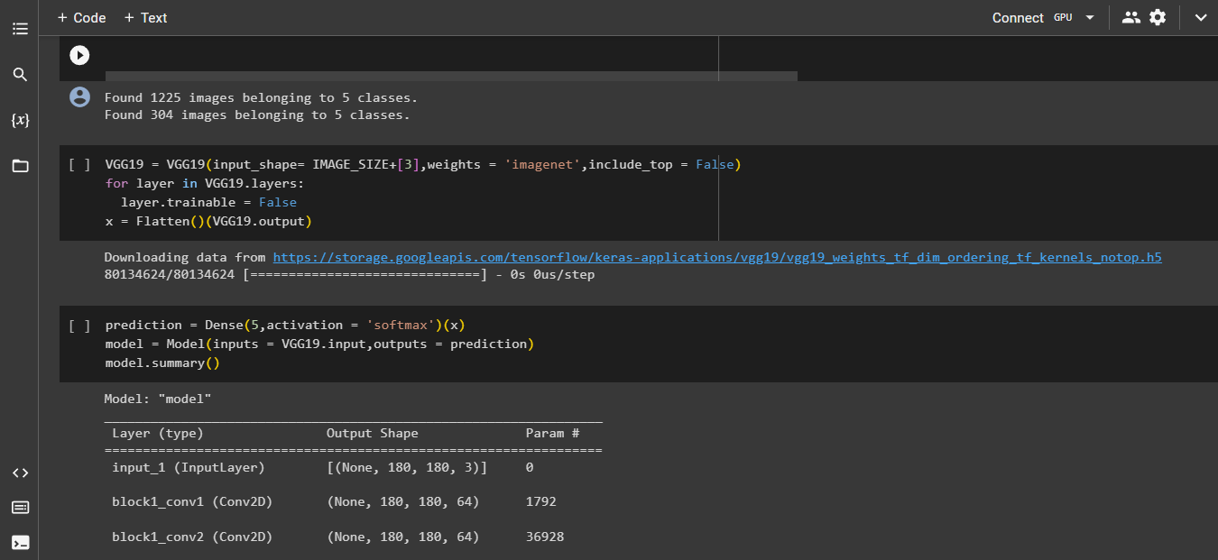
4.5 BUILDING THE MODEL
Here we make use of a pretrained model VGG19 as a feature extractor. Pre-trained models, especially those trained on large and diverse datasets (e.g., ImageNet), have already learned meaningful and generalizable features from the data.
These models have gone through extensive training to extract relevant patterns and features that can be useful for a wide range of tasks, including weather classification.
By utilizing a pre-trained model as a feature extractor, you can leverage these learned features instead of starting from scratch, which can significantly speed up the training process and improve the performance of our model.
Added Dense layers and the activation function “Softmax” is usd for the Mullticlass Classification.

4.6 TRAINING THE MODEL
The optimizer used by our model is “Adam”, it is the most common optimizer used in image classification.
The Loss function used here is “Categorical Crossentropy” which is usually used in the multiclass classification problems where the target variable is labelled not numbered.
After training the model we achieved an Accuracy of 85.71% . Then the model file with h5 extension is saved and it is downloaded as “wcv.h5” 2!
4.7 TESTING THE MODEL

After saving the model we started testing the model with random images from the test dataset which our model never seen before I.e., the images in the test set and training set are different.
We tested our model with two random images both are predicted correctly.

5.RESULT
5.1 EVALUTION OF ACCURACY
Accuracy is an important metric in building an ML model.
The Accuracy of our model is found to be
85.71 %
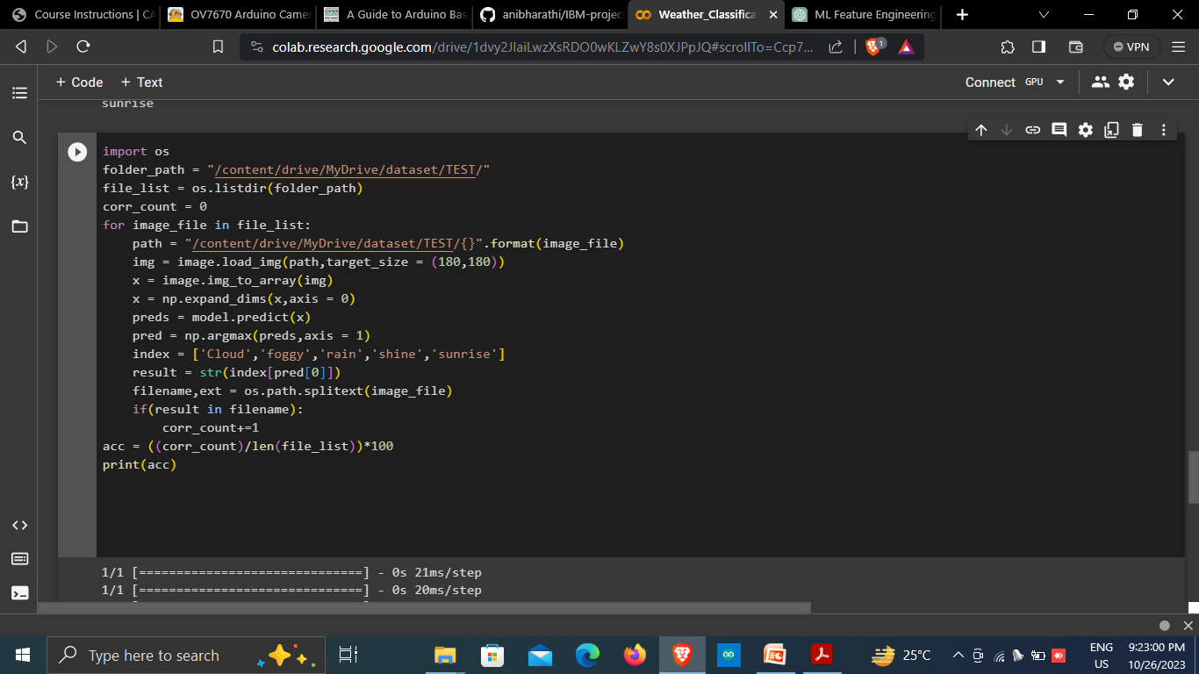

GITHUB LINK:https://github.com/Sakthi123456788/IBM-project

